Jonathon Youngquist, Kevin Zhang, Ryan Wang, Edwin He, Eric Liu, David Lin, Michael Zhou

Introduction
BMart is a digital marketplace for connecting buyers with reliable sellers, focused on helping buyers easily find and compare products while giving both parties a trustworthy experience. It is a way for Bruins to connect with Bruins and facilitate trade.

Impact
Encourage buying and selling between UCLA students through a convenient platform that gives users confidence in digital safety. On this front, we want to capture the majority of market share in the UCLA area, aiming for a user base greater than 50% of UCLA’s student population. We also want to encourage academics in the UCLA population, so we are aiming for a 30% increase in the number of sales in the school category from year 1 to year 2.

Primary Issues
- Lack of a quality report system for bad actors. Existing products either do not have a way to remove problematic content (Facebook Marketplace), or have a poor UI and no SLA on feedback (MySchoolMarket).
- Buyer/Seller Ratings. Existing products lack systems to easily gauge credibility of other users. MySchoolMarket lacks a rating system entirely, while Facebook Marketplace’s rating system is hard to access, or completely inaccessible on certain platforms.

User Personas
Buyers:
- Need to view product listings
- Need to search products by name and sort by seller rating
- Need to mark interest in product listing
- Need to rate sellers
- Buyers frustrated by lack of transparency on sellers
Sellers:
- Need to list products
- Need to see buyers interested in product and accept buyer seller wants to engage in transaction with
- Need to rate buyers

Success Metrics
User Experience/Engagement Metrics:
- < 45 second average time to create a new listing
- > 40% of users use search
- 1-3 inquiries per listing
- Average rating of > 3/5 for sellers and buyers
- < 5 second search latency
- > 70% search success rate
- > 70% of reported fraudulent listings removed within 48 hours
Transaction Metrics:
- > 10% of listings convert to sales
- < 7 days for fast-moving items, < 30 days for slower categories

Core Features
- Account Creation
  - Users create accounts with UCLA email verification
  - Provide contact information to connect
- Item Posting
  - Postings with images, text,category, and condition tag
  - Requested sale prices
- Buyer/Seller Matching
  - Buyers express interest
  - Sellers select buyers to connect with
- Rating/Ranking System
  - Buyers/sellers can leave ratings on sellers/buyers after transactions
  - Buyers can sort item postings by rating
  - Sellers can sort interested buyers by rating
- Reporting & Removal of Problematic Postings
  - Users can report item postings or accounts
  - Problematic postings with too many reports will be taken down
  - Postings for stolen items may be taken down
- Search System
- Sellers can search by name
- Sort by rating
- Filter by price, condition, category

Technical Requirements
- Performance
  - Less than 5 seconds load requirement
- Rendering
  - Able to render every important aspect of the mock up
- Scale
  - Able to support several users at once
  - Be able to handle roughly 50k accounts
  - Able to handle 100k store items
- Security
  - Accounts are not easily broken into
  - Account information can be made private

User Flow / Journey
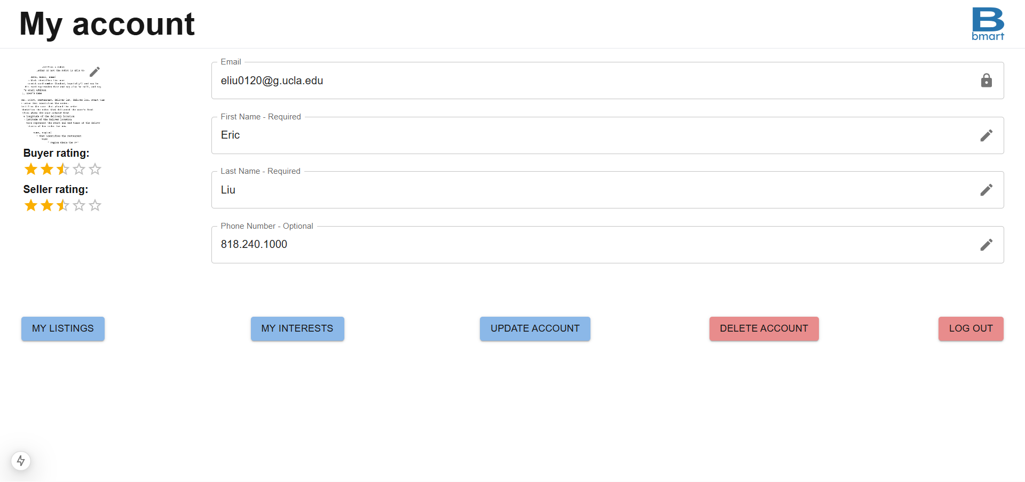
Creating Account
- If user isn’t logged in, the sign in page is rendered, where they can sign in/sign up with their school email address using Google authentication
- This will take user to the ‘My Account’ page where you can enter your personal details
- Once logged in, the user can access the product listings and the seller home

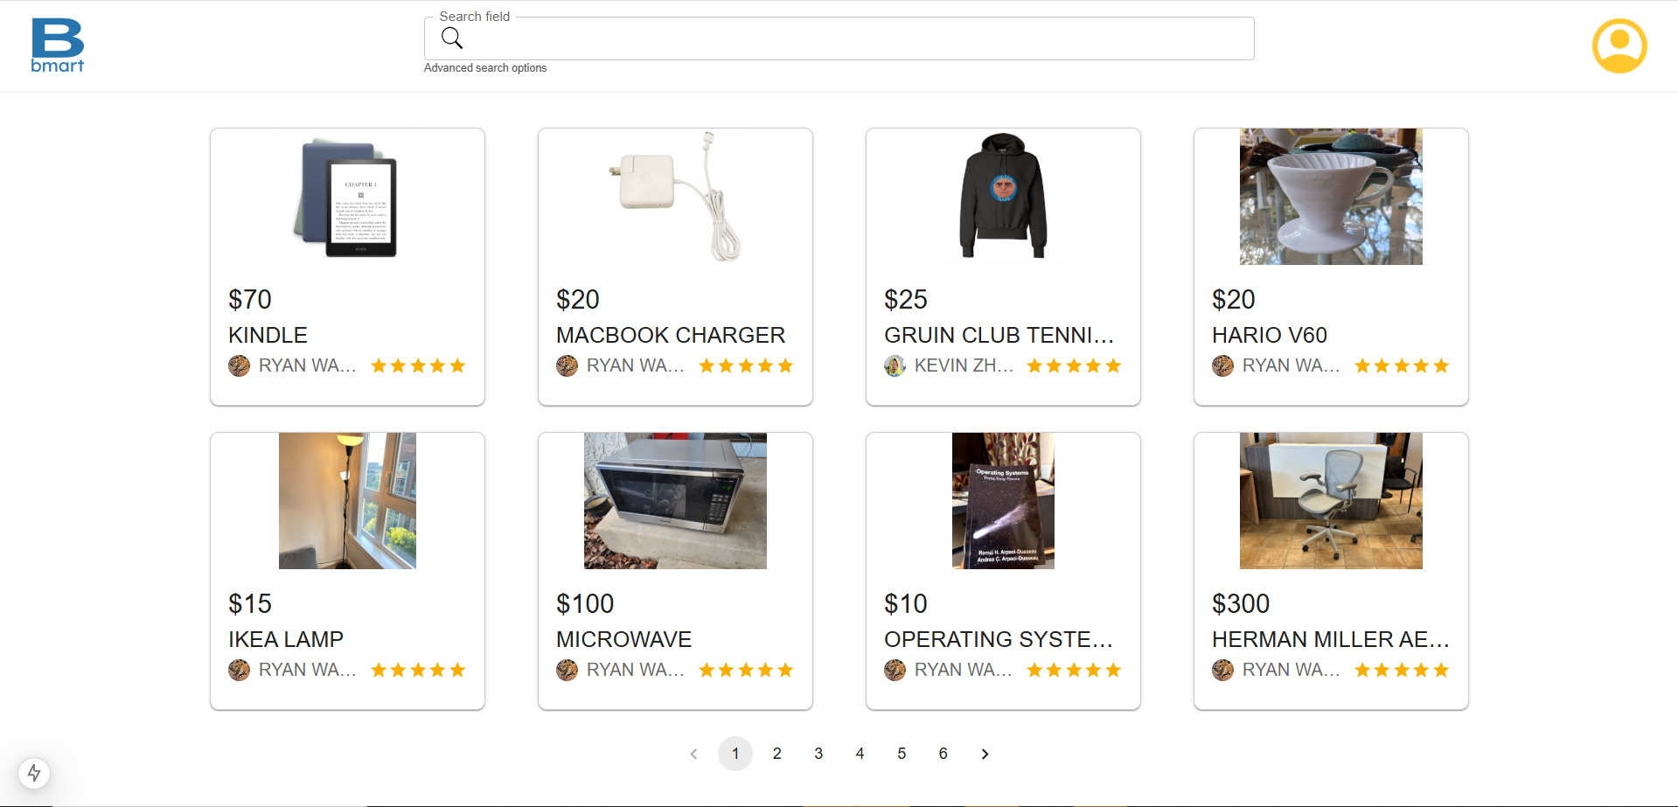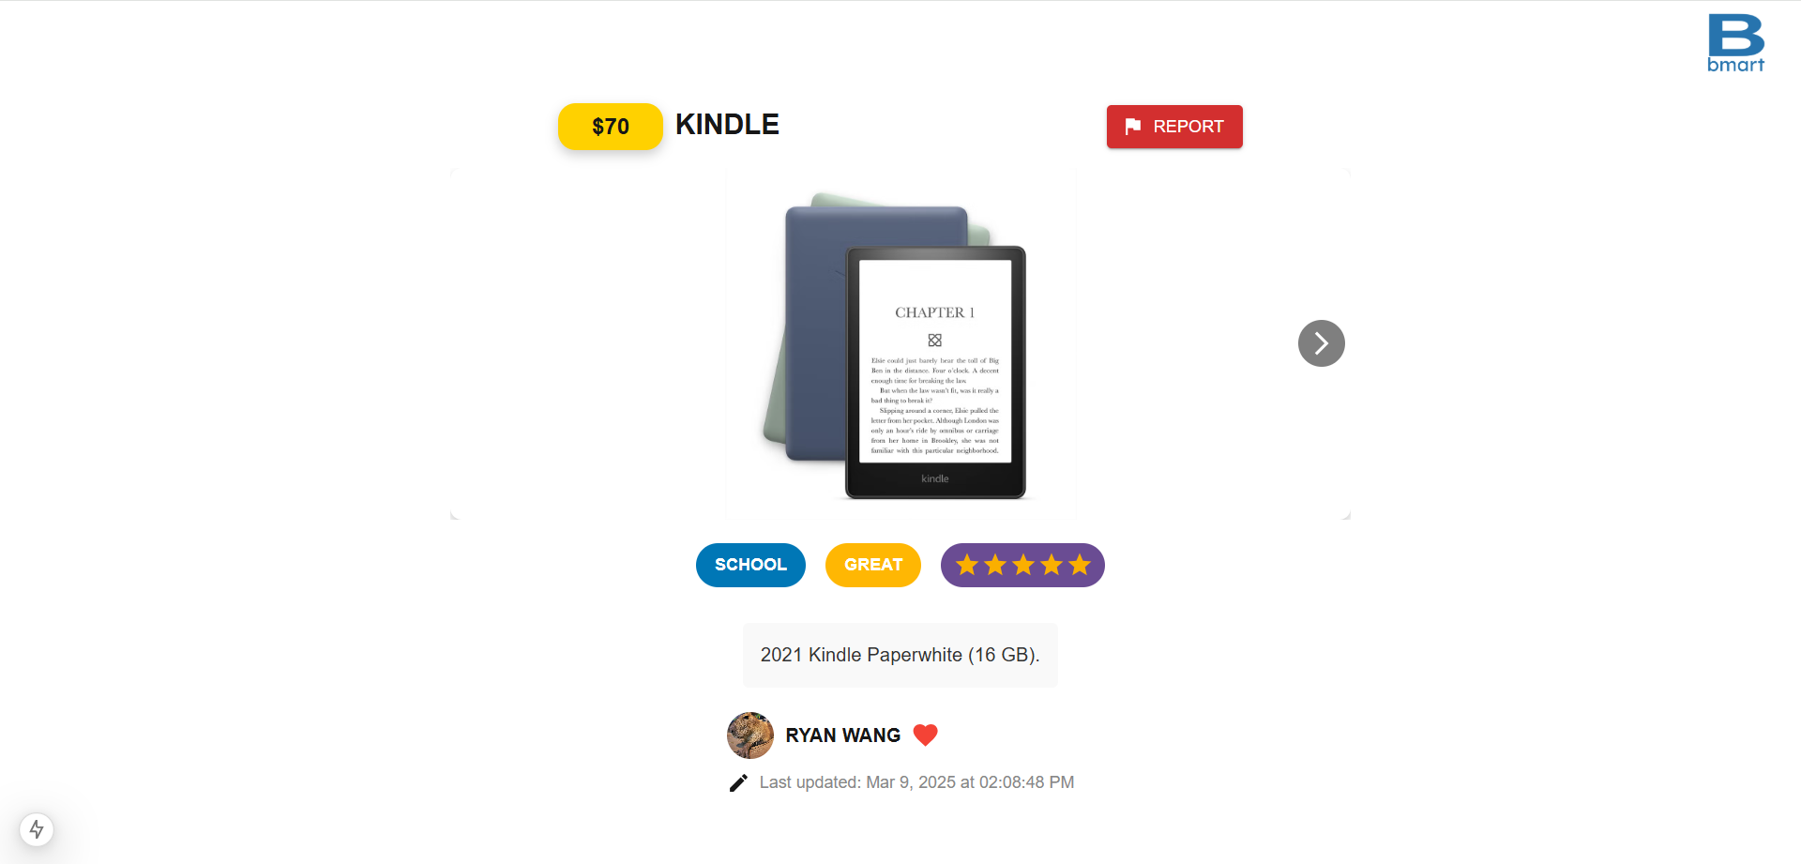
Buying a Product
- User scrolls through a grid of listings or uses search bar
- User then selects listing of interest, which then pops up with listing details
- If interested, the user can express interest in the item; the seller may then accept the buyer’s request, resulting in a match
- Once the transaction is finished, the user can rate the seller out of a scale from 1-5
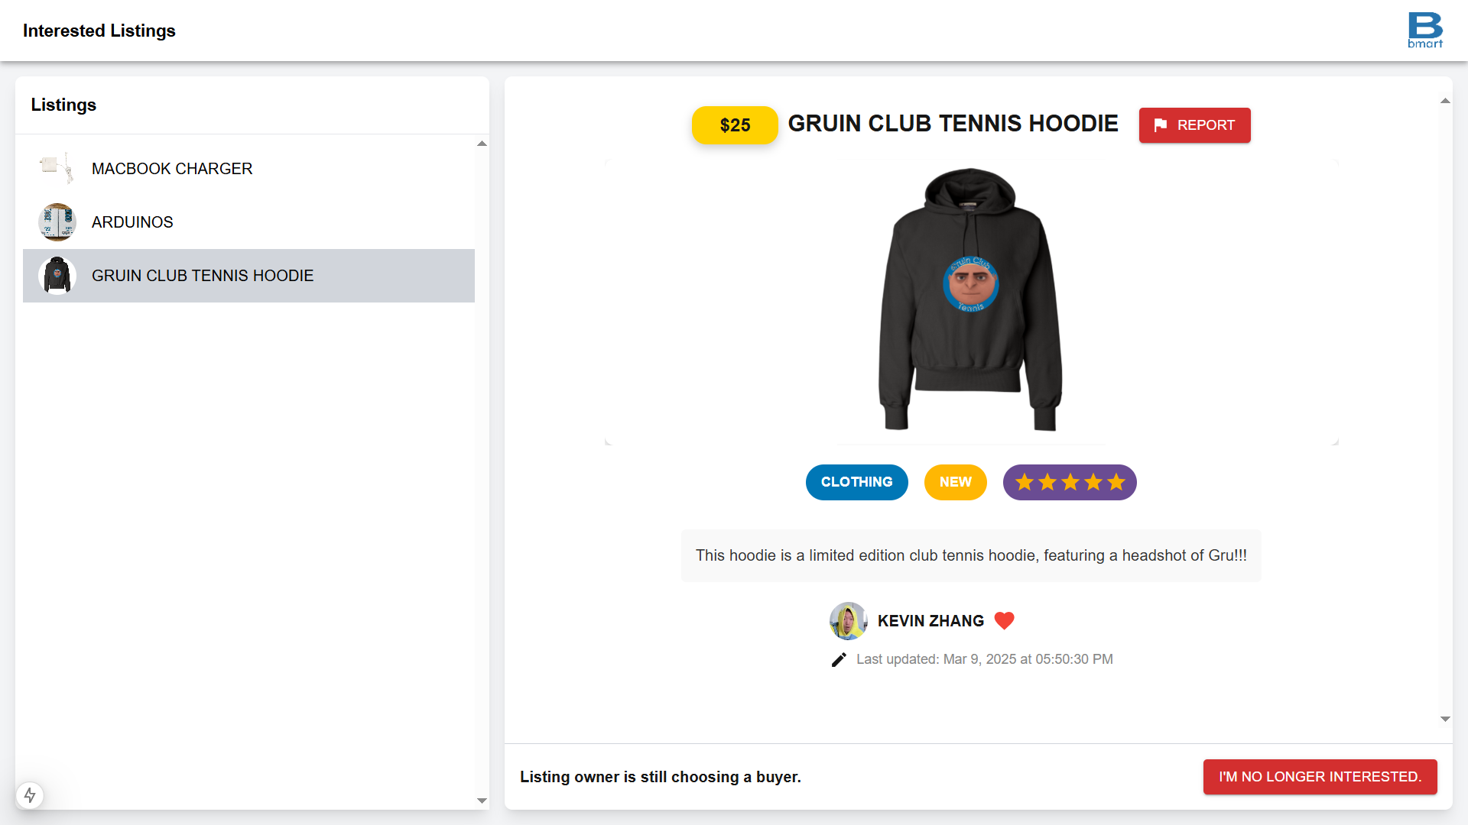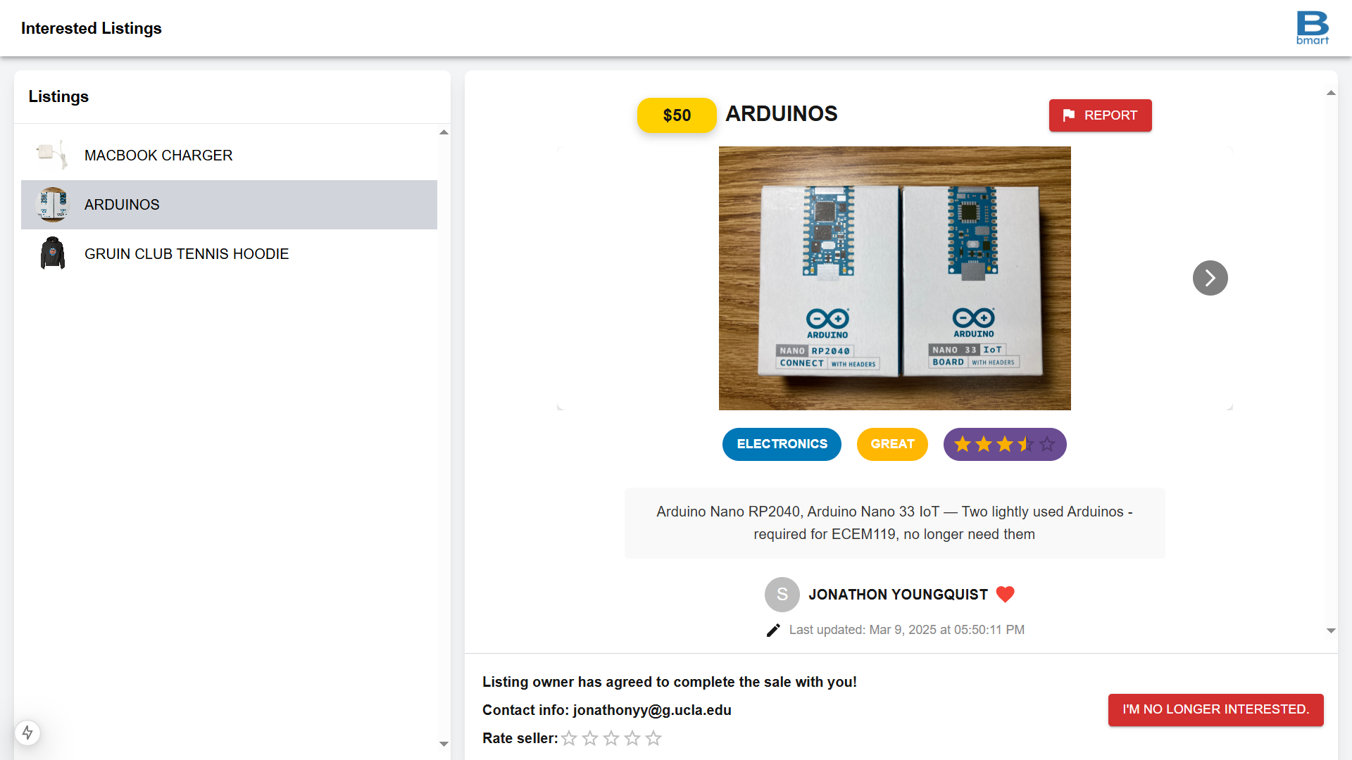
Seller Home
- Page shows up with each of the seller’s listings on the left, and the corresponding interested buyers are on the right
- Seller can accept buyer
- Once the transaction is finished, the user can rate the buyer out of a scale from 1-5
- User can Create New Listing and Modify Listings here
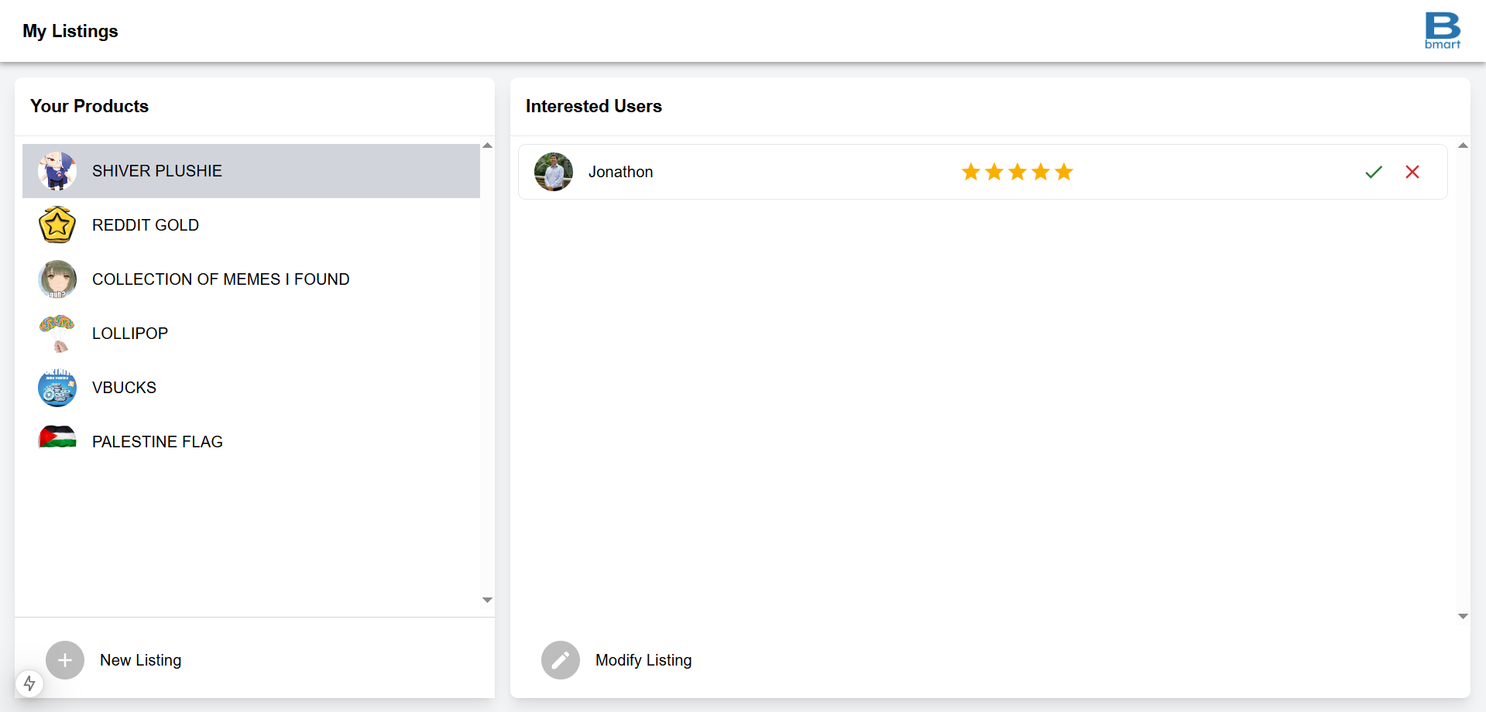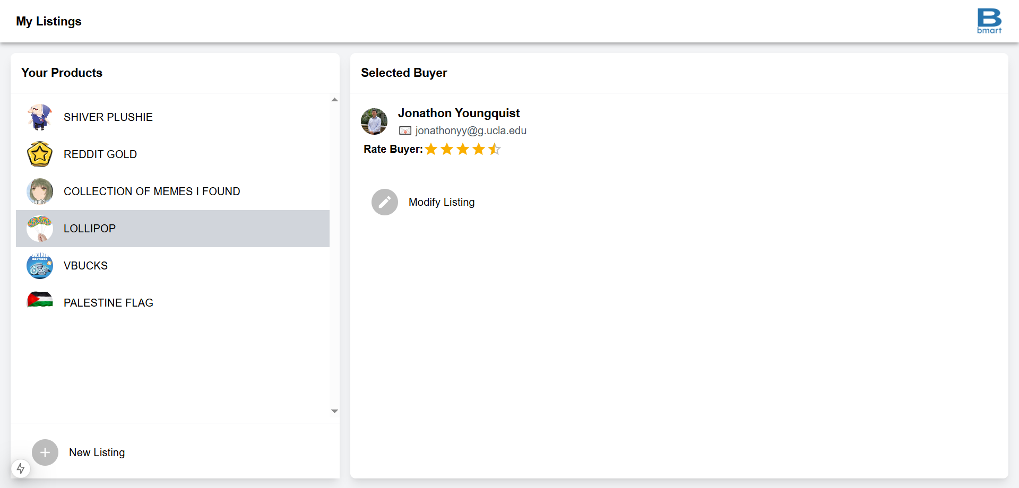

Creating New Listing
- Form shows up with: Title (required), Price (required), Description (required), Condition (select from options), Category (select from options)
- User then selects image(s) to upload (required)
- User can then review the details of the listing and submit it to the shop
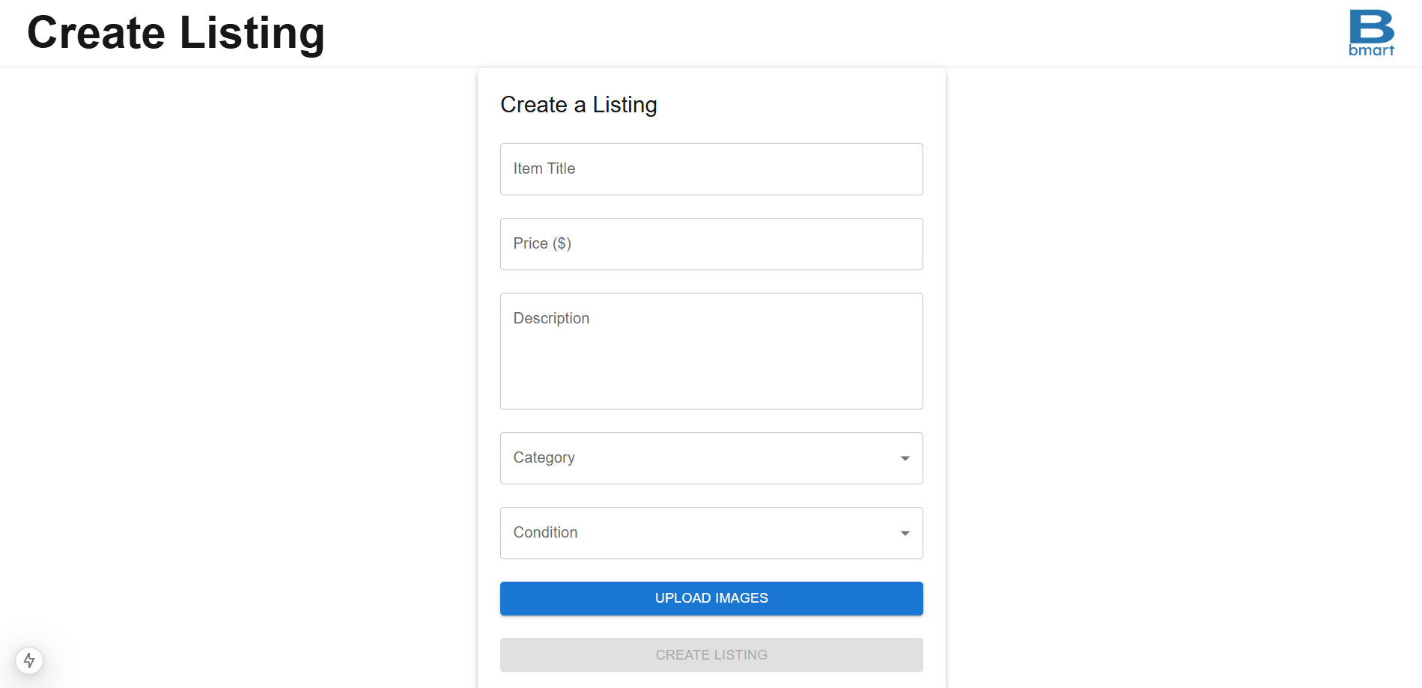
Modifying a Listing
- Form shows up with all previously inputted details of the listing
- User can then review the details of the listing and either edit and resubmit or delete the listing
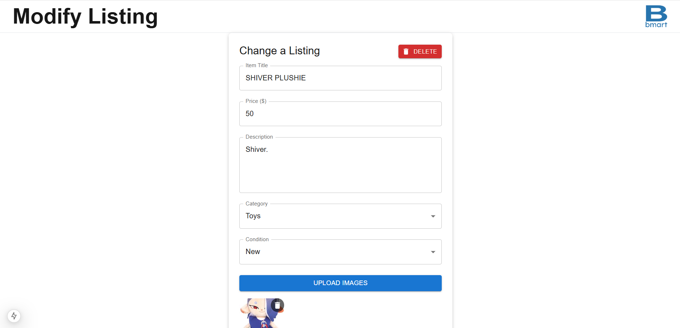

Dependencies
- Front-end
  - React.js
  - MUI
- Back-end
  - Firebase/Firestore
  - Node.js/Next.js
- Login/Authentication
  - Google OAuth

Milestones
- Week 5 (2/7):
  - Initial frontend skeleton; initialize backend framework
- Week 6 (2/14):
  - Complete UML diagrams and Design Doc
  - Complete API; complete skeletons of each frontend page
- Week 7 (2/21): Part B due
  - Finalize backend and database
  - Continue development of frontend pages; translate Figma to React
  - Create necessary unit tests
- Week 8 (2/28):
  - Complete frontend implementation; connect to backend
  - Begin advanced features
- Week 9 (3/7):
  - Finish implementing advanced features
  - Run more unit tests to ensure all features are working

Risk Mitigation
- Technical Risks
- Rate limiting
- Storage limiting
- Business Risks
- Competitor analysis and differentiation strategy
- Abuse prevention through report system
- Security Risks
- User authentication
- Data encryption standards

Achievements
- Core Features
- Users are able to create accounts with email validation, restricted to UCLA emails
- Users can create and modify listings with images, descriptions, category tagging, condition tagging, and pricing
- Buyers are able to express interest in listings, sellers are able to select buyers to connect with
- Buyers and sellers can rate seller/buyer after transaction, and listings are sorted by rating
- Users can report listings, listings with too many reports are removed. Users are not able to report accounts due to potential abuse of such a feature
- Users can search by name and filter by category, condition, seller, and price
- Technical Requirements
- After compiling the application has less than 5 second load time for all functionalities and pages. Compilation time depends on network strength.
  - Pages may take longer to render large images, pages will initially load without images and continue loading images
- Able to render all important components and features shown in Figma
- Able to support several users at once and theoretically up to 100k listings and 50k user accounts without significant performance regression
- Account data are protected by authentication and standard data encryption
- Future Extensions
- Improve scalability of home page - currently because of how pagination is set up via MUI, home page can only show up to 10k listings total (including all pages of the home grid). Improvement would be to have pagination be able to make additional fetch requests to get the next 10k listings when needed.
  - API is implemented with Firebase query cursors, so it already supports pagination for future scaling
- Increase user base in the UCLA community
- Continue to monitor long term success metrics

PRD Google Docs Link:
https://docs.google.com/document/d/1nunUopGmCOXK2zTlfauEbAM2XN9K3Yy9sXuEzI-QNdU/edit?usp=sharing

